
Hengjiu Kang
UCD FSAE 2015
Electrical group design document
XBEE PCB design guide

Author: Hengjiu Kang
Date: Feb.4 2015
Document record: n/a
Revision ver 0.1

XBEE Pinouts: 3
XBEE pin connection chart: 4
POWER: 5
UART/SPI pins 6
LED indicator: 7

XBEE Pinouts:

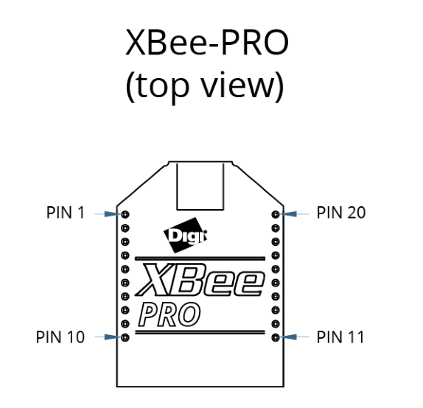

XBEE pin connection chart:

Pin on Cypress |  | Pin on XBEE | Pin on XBEE | Pin on Cypress
VCC(3.3) |  | 1 VCC(3.3) | 20
P4[2] (80) | UART_rx | 2 DOUT | 19 SPI_nATTN | NC | NC
P4[0] (69) | UART_tx | 3 DIN | 18 SPI_SCLK | XBEE_CLK | P4[5] (83)
P4[4] (82) | SPI_MISO | 4 SPI_MISO | 17 SPI_nSSEL | XBEE_SS | P4[6] (84)
P4[7] (85) | XBEE_RST | 5 nRESET | 16
 |  | 6 | 15 Associate |  | External LED
 |  | 7 | 14 VRef |  | GND
 |  | 8 | 13 On_nSLEEP | NC | NC
 |  | 9 | 12
GND |  | 10 | 11 SPI_MOSI | SPI_MOSI | P4[3] (81)

Mark:
- Leave all unused pins disconnected.
- NC means “no connect”
- Add a jumper between Xbee pin15(associate) to LED. For compatibility.
- Because we will not use secondary programmable chip, so just connect Xbee pin 14 to GND.
- XBEE pin 19 will not be used, because in our design, Xbee on logger only send out data.
- More notices are on following chapters.

POWER:
XBEE dose not have special requirements for powering expect for some basic suggestions:
- “To help reduce noise, we recommend placing both a 1uF and 47 pF capacitor as near to pin 1 on the printed circuit board (PCB) as possible. ”
- “If you use a switching regulator for your power supply, switching frequencies above 500 kHz are preferred. Limit the power supply ripple to a maximum 50mV peak to peak.”

UART/SPI pins

UART:
UART only requires two wires: Tx and Rx
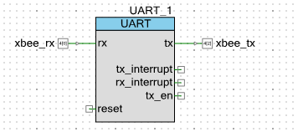

SPI:
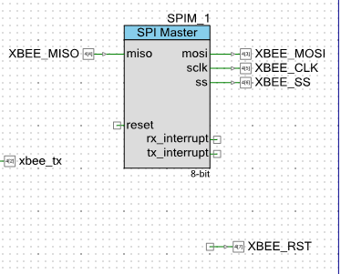

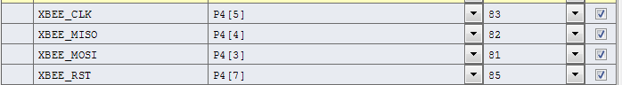

LED indicator:
